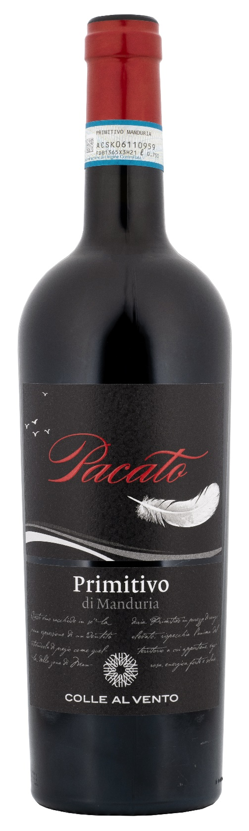
PRIMITIVO DI MANDURIA DOP – PACATO

Grape: Primitivo 100%
Alc. Vol.%: 14,5
Vintage: 2024
Residual sugar g/l: 7,6
Total acidity g/l: 5,9
Region: Apulia
Production zone: Vineyards in the area of Manduria and Sava (Taranto)
Capacity: 750ml

CHARACTERISTICS

Vinification: After a soft pressure and the separation of grape-stalk, traditional short maceration and fermentation at a controlled temperature, with several pump-overs for a better extraction of colour and tannins
Aging: 8 months
Yield per ha: 9000kg
Colour: Intense red with purple reflections
Bouquet: Aromas of mature fruits and spices
Flavour: Complex, pleasant and persistent

SERVING SUGGESTIONS

Excellent with red meat dishes and matured cheese.
Serving temperature 18 °C
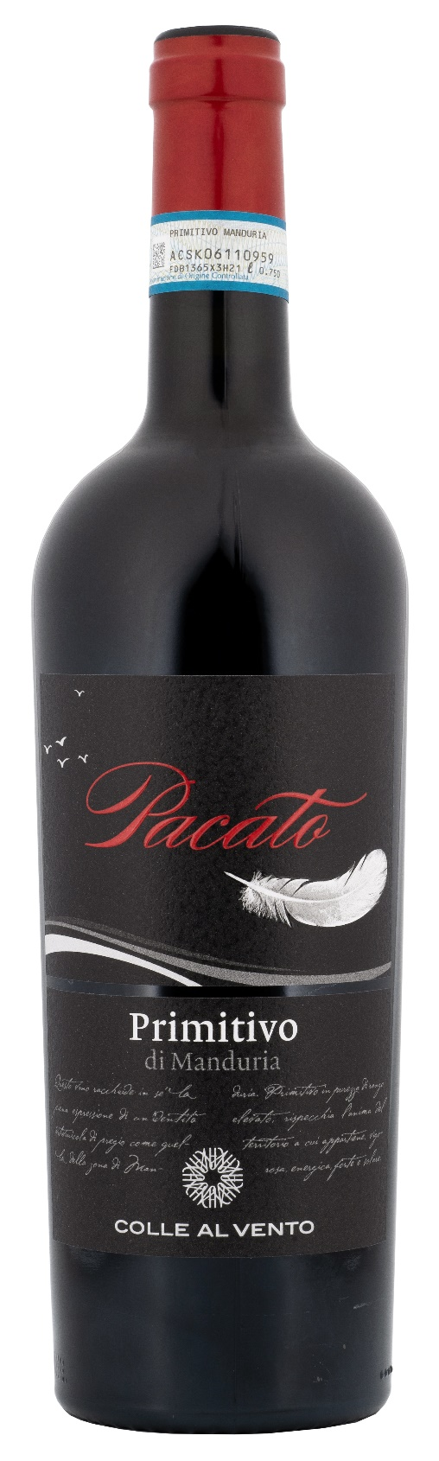
TECHNICAL INFORMATION / PALLETIZING

Size 750ml:
Article Nr. V03003A
GTIN-13 bottle 8017868001614
GTIN-13 carton 8017868001621
Closure Cork
Bottles / carton 6 bottles
Pallet size 80x120cm
Cartons/layer 21
Cartons/pallet 105
Kg/carton 8,1
Kg/pallet 870

Contains sulphites
GMO Free
Revisione 01. 14.05.2026

